TIME
Pearson Edexcel - Thursday 4 June 2020 - Paper 2 (Calculator) Foundation Tier

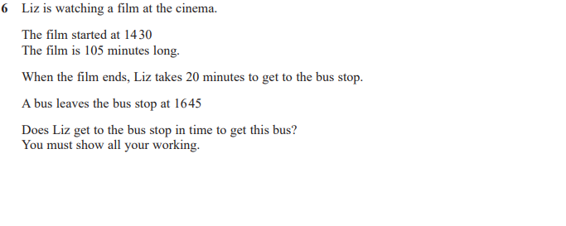

Pearson Edexcel - Tuesday 21 May 2019 - Paper 1 (Non-Calculator) Foundation Tier

Pearson Edexcel - Thursday 6 June 2019 - Paper 2 (Calculator) Foundation Tier

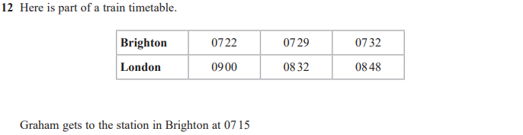
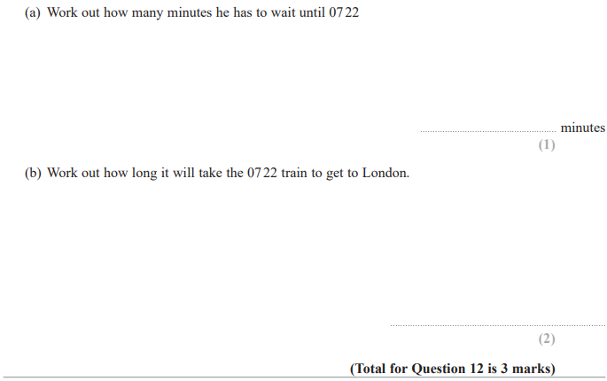

Pearson Edexcel - Tuesday 12 June 2018 - Paper 3 (Calculator) Foundation Tier

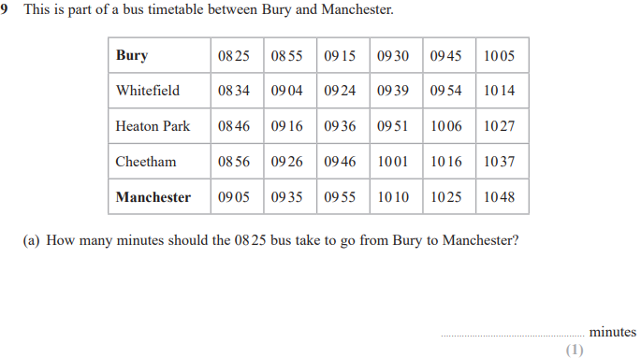
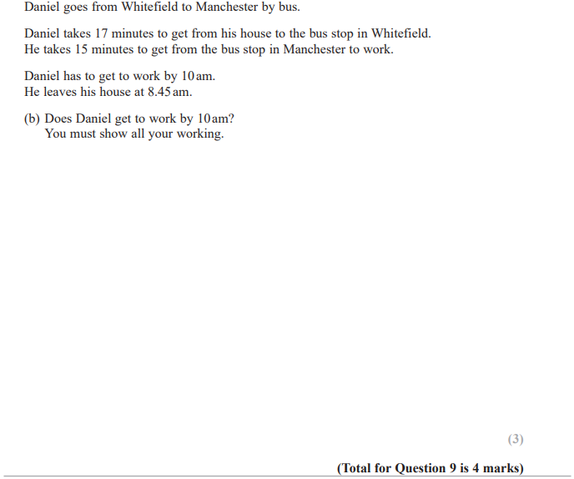

Pearson Edexcel – Specimen 2 - Paper 2 (Calculator) Foundation Tier

Pearson Edexcel - Wednesday 8 November 2017 - Paper 3 (Calculator) Foundation Tier

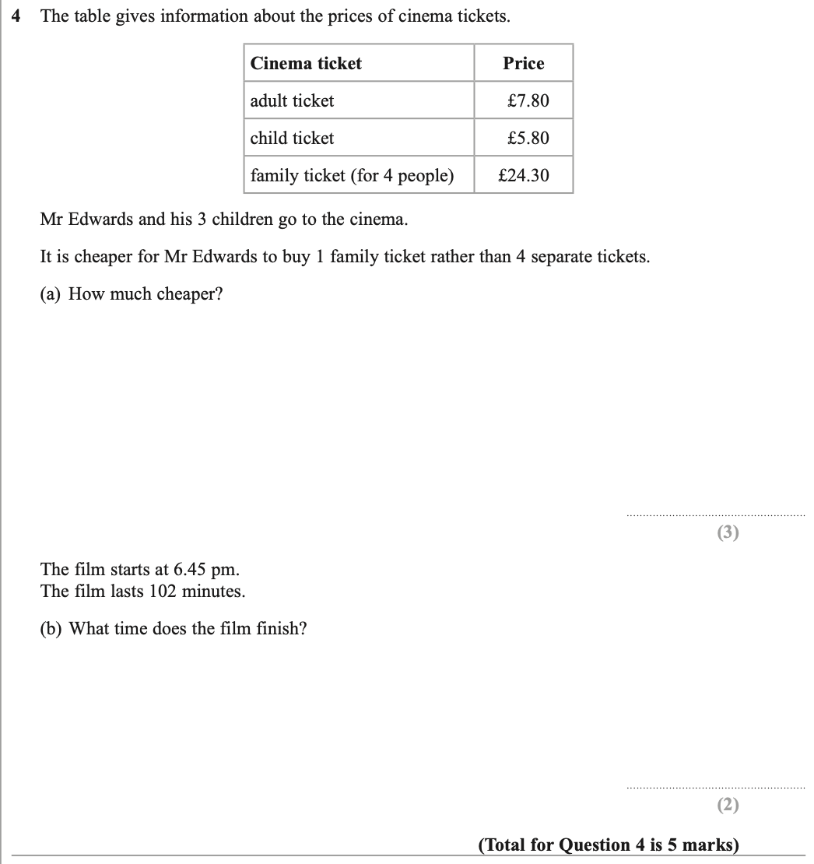

Pearson Edexcel – Specimen 2 - Paper 2 (Calculator) Foundation Tier

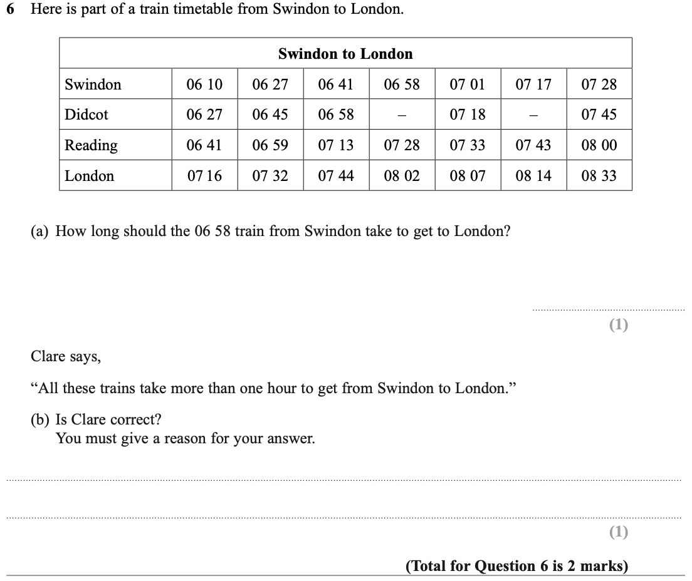

Pearson Edexcel – Specimen 1 - Paper 1 (Non-Calculator) Foundation Tier
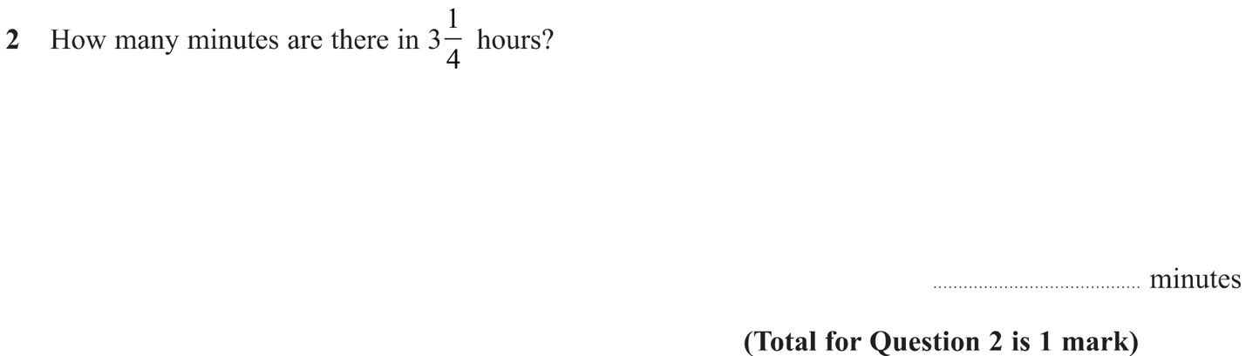

OCR Thursday 05 November 2020- Morning (Non-Calculator) Foundation Tier
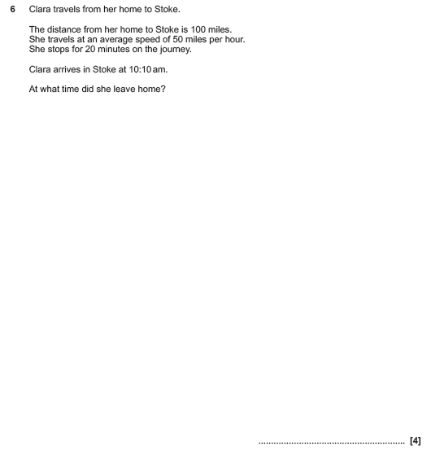

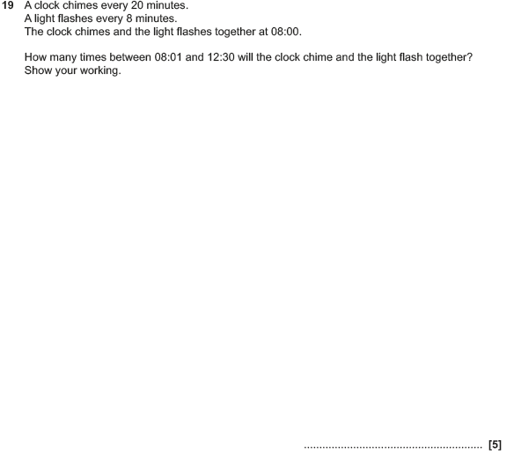

OCR Thursday 07 November 2019- Morning (Non-Calculator) Foundation Tier
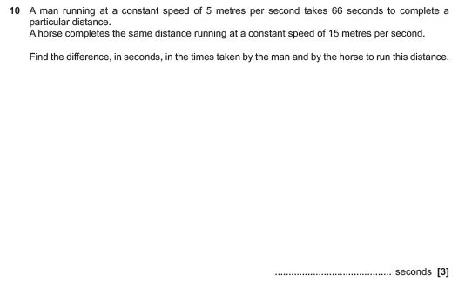

OCR Tuesday 21 May 2019 – Morning (Calculator) Foundation Tier
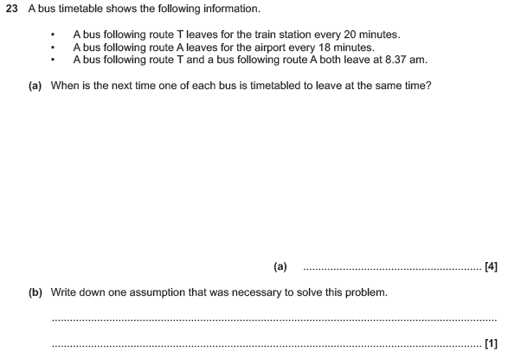

OCR Tuesday 11 June 2019 – Morning (Calculator) Foundation Tier

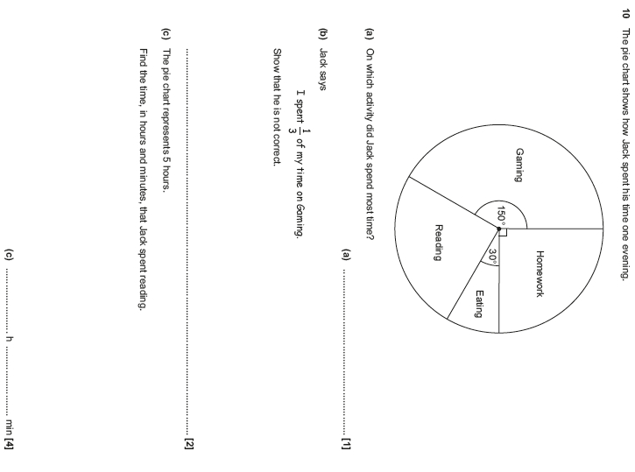

OCR Tuesday 6 November 2018 – Morning (Calculator) Foundation Tier
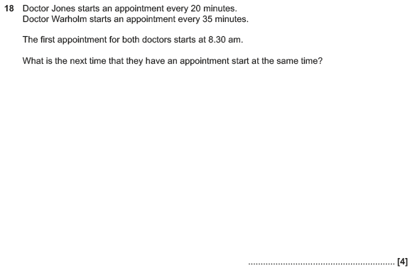

OCR Thursday 25 May 2017 – Morning (Calculator) Foundation Tier

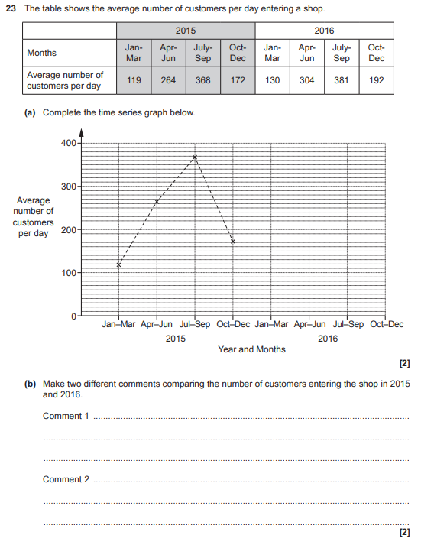

OCR Sample Question Paper 3 – Morning/Afternoon (Calculator) Foundation Tier

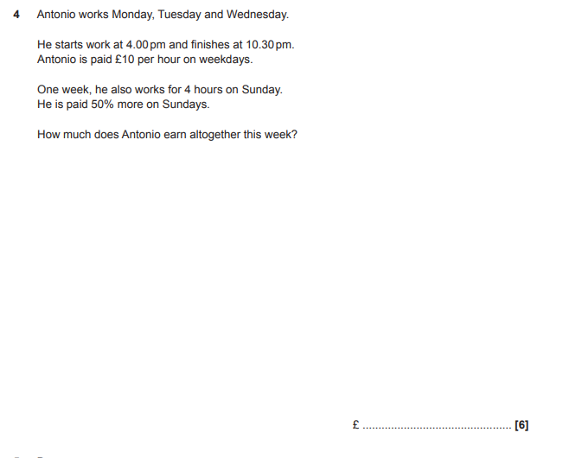

AQA Tuesday 19 May 2020 – Morning (Non-Calculator) Foundation Tier

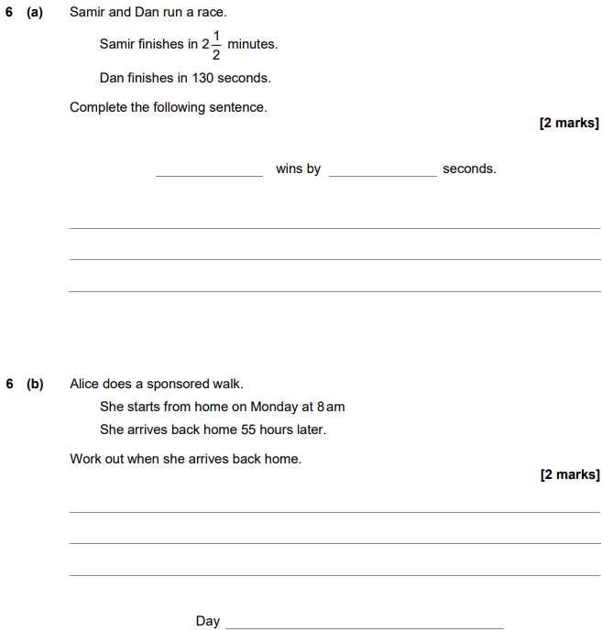

AQA Thursday 6 June 2019 – Morning (Calculator) Foundation Tier

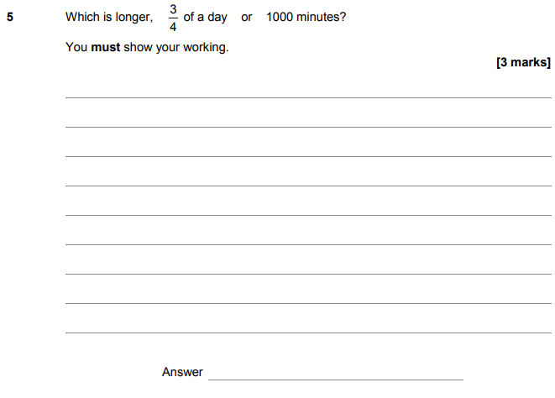

AQA Monday 12 November 2018 – Morning (Calculator) Foundation Tier

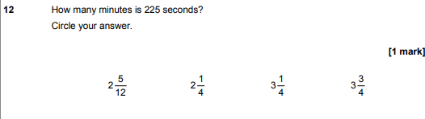

AQA Thursday 24 May 2018 – Morning (Non-Calculator) Foundation Tier

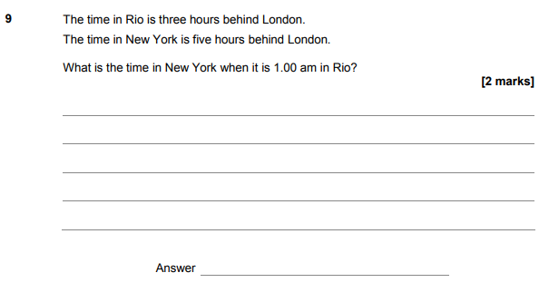
AQA Thursday 7 June 2018 – Morning (Calculator) Foundation Tier

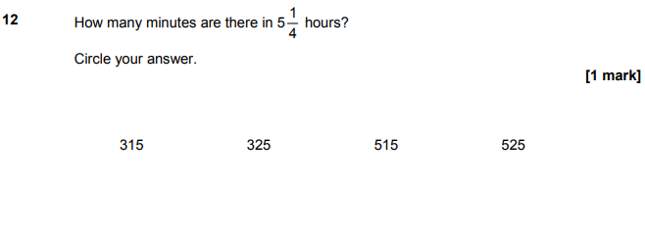

AQA Monday 6 November 2017 – Morning (Calculator) Foundation Tier

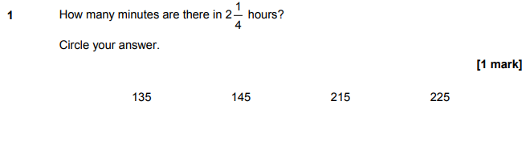
AQA Thursday 25 May 2017– Morning (Non-Calculator) Foundation Tier

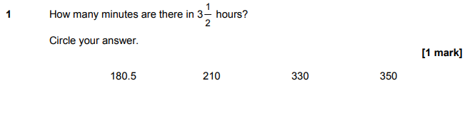
AQA Tuesday 13 June 2017 Morning– Morning (Calculator) Foundation Tier

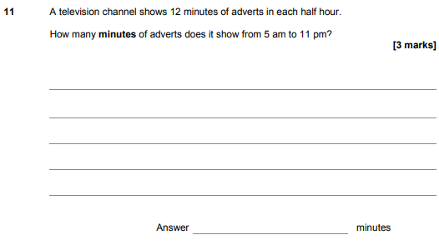
AQA Sample Paper 1– Morning (Non-Calculator) Foundation Tier

